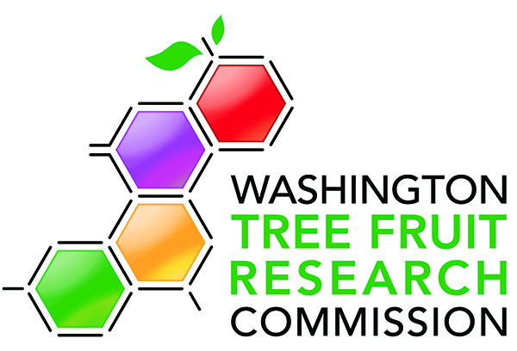
2022 Request for Proposals (RFP) for Technology

The Washington Tree Fruit Research Commission (WTFRC) is seeking proposals for technology. Technology projects for apples or across different crops (apples, cherries, pears, stonefruit) are encouraged. Of special interest are proposals addressing methods assessing labor utilization or for the reduction of manual labor needs in orchards.

- Partial or full automation of:
  - Harvest automation for apple, pear, stonefruit, and cherry.
    - Three state (CA/OR/WA) collaboration to automate cherry harvest.
  - Pruning – Cutting selected branches on a tree to achieve desired crop load.
  - Thinning – Removal of fruit from the tree- manual, physiological.
  - Spraying – Adoption of precision crop protection application methods (needs to include efficacy data).
  - Insect monitoring - Automated insect monitoring and scouting programs.
- Plant health monitoring with sensors.
- Non-destructive crop stress modeling.
- Smart Orchard Project – Give growers the tools to assess and make critical decisions.
- Accurate crop estimation (yield, size profile) / real time fruit growth measurement.
- Cost-effective high-density growing systems or manipulation of existing systems for efficient automation.
- Economic analysis: For available and novel technologies (how to make the economics work), focus on Key Performance Indicators (KPI’s)

Some of the priorities listed do not specifically ask for organic options. We are interested in having organic practices considered in all proposed work, when appropriate. Also, proposals are expected to include an industry outreach component if the sought-out project outcomes are anticipated to directly translate into management changes. Maintaining profitable and sustainable tree fruit companies is of utmost importance to our industry and economic considerations need to be included in project designs.
Novel ideas in areas not listed as priority are encouraged. Please feel free to contact Ines Hanrahan (hanrahan@treefruitresearch.com) to discuss any ideas outside of the priorities identified by the 2022 Request for Proposals (RFP) before submitting a preproposal.
Detailed instructions for preproposal submissions may be found at: https://treefruitresearch.org/proposals-reports/pre-proposal/instructions/
Preproposals should be submitted by September 8, 2021, to: amy@treefruitresearch.com
For general information about the funding process please consult the Proposal, Review, and Funding Process Description Document: https://treefruitresearch.org/proposals-reports/new-researcher-onboarding/
For more information or context please contact: hanrahan@treefruitresearch.com

